Software Testing Report

Sydney Airbnb Application

Viet My Tran Le s5235877   
William Luvant s5287580  
Liangxian Zhao s2869753

Table of Contents

1.0 Unit Tests 3

2.0 Coverage Report 15

3.0 Requirements Acceptance Testing 22

# Unit Tests

| **No** | **Test Case** | **Expected Results** | **Actual Results** |
| --- | --- | --- | --- |
| **1.0** | **Data loading Functions** |  |  |
| 1.1 | Loading a wrong database | Display error message and exit | Display error message and exit |
| 1.2 | Test without existing SQL database | Exception handled: pass and print "Not Exist!" | Exception handled: pass and print "Not Exist!" |
| 1.3 | Test with already inserted SQL database | Exception handled: pass and print "Data Already Exists!" | Exception handled: pass and print "Data Already Exists!" |
| **2.0** | **Report the information of all listings in a specific timeframe** |  |  |
| 2.1 | Test Setup retrieves by time | User can input their desired time | User can input their desired time |
| 2.2 | Test search | Display all properties within that timeframe | Display all properties within that timeframe |
| **3.0** | **Report the information of all listings in a specific price range** |  |  |
| 3.1 | Test search with valid price range | Display all properties within that price range | Display all properties within that price range |
| 3.2 | Test search with invalid price range | System won’t display anything | System won’t display anything |
| 3.3 | Test draw picture | Display all properties prices in a histogram | Display all properties prices in a histogram |
| 3.4 | Test back main window | System goes back to previous window | System goes back to previous window |
| 3.5 | Test on close window | Window is closed | Window is closed |
| **4.0** | **Report the information of all listings in a specific keyword** |  |  |
| 4.1 | Test search with keyword | Display all properties containing that keyword | Display all properties containing that keyword |
| 4.2 | Test search with invalid keyword | System won’t display anything | System won’t display anything |
| 4.3 | Test search with empty keyword | System will display everything | System will display everything |
| 4.4 | Test draw picture | Display all keywords in a histogram | Display all keywords in a histogram |
| 4.5 | Test back main window | System goes back to previous window | System goes back to previous window |
| 4.6 | Test on close window | Window is closed | Window is closed |
| **5.0** | **Analysing how many customers commented on factors related to cleanliness** |  |  |
| 5.1 | Mock read csv | Display predefined Data Frame | Display predefined Data Frame |
| 5.2 | Test draw chart | Display graphs based on cleanliness keyword | Display graphs based on cleanliness keyword |
| 5.3 | Test on Retrieve keywords from database | System can retrieve all keywords from the database | System can retrieve all keywords from the database |
| 5.4 | Test on Select keyword desired | User can select the keyword they want | User can select the keyword they want |
| 5.5 | Update database | Database is updated | Database is updated |
| **6.0** | **Show the rating of properties based on the customers’ experience and their satisfaction toward the property** |  |  |
| 6.1 | Retrieve ratings from database | System can retrieve all ratings from the database | System can retrieve all ratings from the database |
| 6.2 | Test on Setup UI | Prepare the data frame | Prepare the data frame |
| 6.3 | Test on Graph display | Display graphs based on ratings | Display graphs based on ratings |

**Feature 1: Report the information of all listings in a specific suburb**

import pytest  
from unittest.mock import MagicMock, Mock  
import sqlite3  
import wx  
  
from f1 import Retrieve_By_Time  
  
  
class MockGUI:  
 def GetValue(self):  
 return "2022-01-01"  
  
  
@pytest.fixture  
def setup_retrieve_by_time(monkeypatch):  
 con = MagicMock(spec=sqlite3.Connection)  
 cur = MagicMock(spec=sqlite3.Cursor)  
  
 con.cursor.return_value = cur  
 cur.fetchall.return_value = []  
  
 monkeypatch.setattr("sqlite3.connect", lambda _: con)  
  
 # Mock wx.App and instantiate it  
 class MockApp(wx.App):  
 def OnInit(self):  
 return True  
  
 mock_app = MockApp(redirect=False)  
 monkeypatch.setattr(wx, 'App', MockApp)  
  
 # Mock wx.MessageBox  
 monkeypatch.setattr(wx, 'MessageBox', Mock())  
  
 frame = Retrieve_By_Time(None)  
 frame.file1 = MockGUI()  
 frame.file2 = MockGUI()  
  
 return frame, con, cur  
  
  
def test_search(setup_retrieve_by_time):  
 frame, _, cur = setup_retrieve_by_time  
  
 # Mocking the GetValue methods  
 frame.file1.GetValue = Mock(return_value='2022-01-01')  
 frame.file2.GetValue = Mock(return_value='2023-01-01')  
  
 frame.search(Mock())  
  
 expected_sql = ("select * from Listings_Dec18 where id in "  
 "(select distinct listing_id from Calendar_Dec18 where "  
 "substr(date,1,4) || substr(date,6,2) || substr(date,9,2) "  
 "between '20220101' and '20230101')")  
  
 cur.execute.assert_called_with(expected_sql)

**Feature 2: Report the information of all listings in a specific price range**

import pytest  
import wx  
from f2 import Housing_Price_Trend  
  
mock_mean_price = {'price': {'Entire home/apt': 200.0, 'Private room': 100.0}}  
  
app = wx.App(False)  
  
@pytest.fixture  
def frame():  
 frame = Housing_Price_Trend(None, title='Housing Price Trend')  
 frame.Show()  
 yield frame  
 frame.Destroy()  
  
def test_file1(frame):  
 # Test if file1 exists and if it can be set and get values  
 assert hasattr(frame, 'file1')  
 frame.file1.SetValue("2021-10-01")  
 assert frame.file1.GetValue() == "2021-10-01"  
  
def test_file2(frame):  
 # Test if file2 exists and if it can be set and get values  
 assert hasattr(frame, 'file2')  
 frame.file2.SetValue("2021-10-31")  
 assert frame.file2.GetValue() == "2021-10-31"  
  
def test_draw_picture(frame):  
 # Test if draw_picture exists and if it can be called with mock_mean_price  
 assert hasattr(frame, 'draw_picture')  
 frame.draw_picture(mock_mean_price)  
  
def test_search(frame):  
 # Test if search exists and if it can be triggered by an event  
 assert hasattr(frame, 'search')  
 frame.file1.SetValue("2021-10-01")  
 frame.file2.SetValue("2021-10-31")  
 search_event = wx.CommandEvent(wx.wxEVT_COMMAND_BUTTON_CLICKED, frame.searchButton.GetId())  
 frame.GetEventHandler().ProcessEvent(search_event)  
  
def test_back_mainWindow(frame):  
 # Test if back_mainWindow exists and if it can be triggered by an event  
 assert hasattr(frame, 'back_mainWindow')  
 back_event = wx.CommandEvent(wx.wxEVT_COMMAND_BUTTON_CLICKED, frame.mainButton.GetId())  
 frame.GetEventHandler().ProcessEvent(back_event)

**Feature 3: Report the information of all listings in a specific keyword**

import pytest  
import sqlite3  
import wx  
from f3 import Keyword_Search  
  
  
@pytest.fixture  
def keyword_search():  
 app = wx.App(False)  
 return Keyword_Search(None)  
  
  
@pytest.fixture  
def mock_connection(mocker):  
 # Mocking the cursor method to return another mock object  
 mock_cursor = mocker.Mock()  
 mock_connection = mocker.Mock()  
 mock_connection.cursor.return_value = mock_cursor  
  
 return mock_connection, mock_cursor  
  
def test_search_db_call(mocker, keyword_search, mock_connection):  
 mock_con, mock_cursor = mock_connection  
 mocker.patch('f3.sqlite3.connect', return_value=mock_con)  
 mocker.patch('f3.wx.MessageBox')  
  
 mocker.patch.object(keyword_search.file1, 'GetValue', return_value='2018-12-07')  
 mocker.patch.object(keyword_search.file2, 'GetValue', return_value='2019-12-06')  
 mocker.patch.object(keyword_search.file3, 'GetValue', return_value='pool')  
  
 try:  
 keyword_search.search(None)  
 except Exception as e:  
 print("Exception during search:", str(e))  
  
 print("file1 value:", keyword_search.file1.GetValue())  
 print("file2 value:", keyword_search.file2.GetValue())  
 print("SQL Query Used:", keyword_search.sql)  
  
 expected_sql = """select * from Listings_Dec18 where id in (select distinct listing_id from Calendar_Dec18 where substr(date,1,4) || substr(date,6,2) || substr(date,9,2) between '20181207' and '20191206')and (id in (select distinct listing_id from Reviews_Dec18 where comments LIKE '%pool%') or id in (select distinct id from Listings_Dec18 where summary LIKE '%pool%') or id in (select distinct id from Listings_Dec18 where description LIKE '%pool%') or id in (select distinct id from Listings_Dec18 where neighborhood_overview LIKE '%pool%') or id in (select distinct id from Listings_Dec18 where amenities LIKE '%pool%'))"""  
  
 assert keyword_search.sql.strip() == expected_sql.strip(), "Mismatch in SQL Query"  
  
 try:  
 mock_cursor.execute.assert_called_once_with(expected_sql)  
 mock_cursor.fetchall.assert_called_once()  
 except AssertionError as ae:  
 print("Assertion error:", str(ae))  
 print("SQL queries executed:", [call[0][0] for call in mock_cursor.execute.call_args_list])  
 raise

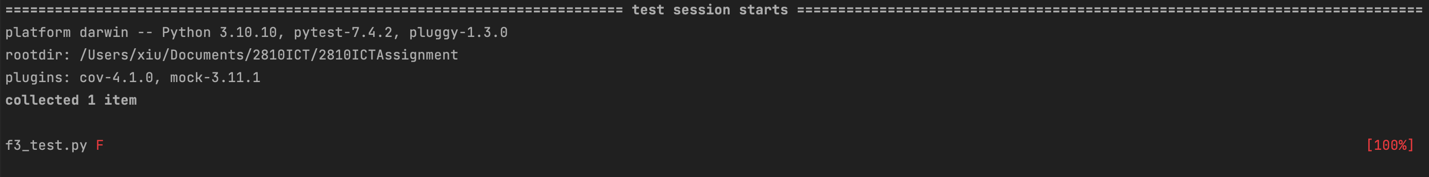

**Feature 4: Analysing how many customers commented on factors related to cleanliness**

import pandas as pd  
import pytest  
from f4 import Cleanliness_Analysing  
from unittest.mock import create_autospec  
  
  
def mock_read_csv(*args, **kwargs):  
 data = {  
 'id': [1, 2, 3],  
 'name': ['a', 'b', 'c'],  
 'property_type': ['Apartment', 'House', 'Condo'],  
 'listing_id': [1, 2, 3],  
 'reviewer_name': ['Alice', 'Bob', 'Charlie'],  
 'comments': ['Very clean!', 'Somewhat clean', 'Not clean at all'],  
 }  
 return pd.DataFrame(data)  
  
@pytest.fixture  
def frame(mocker):  
 mocker.patch("f4.Cleanliness_Analysing.setup_ui") # Mock setup_ui  
 instance = create_autospec(Cleanliness_Analysing, instance=True) # Create a mock instance of the class  
 mocker.patch.object(instance, 'figure', create=True) # Mock figure attribute after instance creation  
 return instance  
  
  
@pytest.fixture  
def mock_dataframe(mocker):  
 mocker.patch('pandas.read_csv', side_effect=mock_read_csv) # Mock read_csv method  
  
def test_update_chart(frame, mock_dataframe):  
 selected_keyword = "clean"  
 # Test will fail if any exception occurs in the method  
 frame.update_chart(selected_keyword)  
  
@pytest.fixture  
def mock_draw_chart_data():  
 data = {  
 'property_type': ['Apartment', 'House'],  
 'number_of_people': [5, 10]  
 }  
 return pd.DataFrame(data)  
  
def test_draw_chart(frame, mock_draw_chart_data):  
 selected_keyword = "clean"  
 # Test will fail if any exception occurs in the method  
 frame.draw_chart(mock_draw_chart_data, selected_keyword)

**Feature 5: Show the rating of properties based on the customers’ experience and their satisfaction toward the property**

import wx  
import pytest  
from f5 import Properties_Rating  
  
@pytest.fixture(scope='function')  
def app():  
 app = wx.App(False)  
 yield app  
 # Cleanup  
 app.Destroy()  
  
  
@pytest.fixture(scope='function')  
def frame(app):  
 frame = Properties_Rating(None)  
 yield frame  
 # Cleanup  
 frame.Destroy()  
  
  
def test_initialization(frame):  
 # Ensure that the frame is shown  
 frame.Show()  
 wx.Yield()  
 assert frame.IsShown()  
  
  
def test_setup_ui(frame):  
 # Test the setup_ui function  
 frame.setup_ui()  
 assert frame.grid.GetNumberCols() == 5  
  
  
def test_get_page(frame):  
 # Test the get_page function  
 frame.page = 0  
 frame.index = [str(i) for i in range(1, 21)]  
 frame.get_page(None, 1)  
 assert frame.page == 1  
 assert frame.index == [str(i) for i in range(21, 41)]  
  
  
def test_main_button(frame):  
 # Redefining the Signal class to accommodate 'emitted' attribute  
 class Signal:  
 def __init__(self, name=None):  
 self.name = name  
 self.emitted = False  
  
 def connect(self, func):  
 self.slot = func  
  
 def emit(self):  
 if hasattr(self, "slot"):  
 self.slot()  
 self.emitted = True  
  
 # Initialize the mock signal  
 frame.return_signal = Signal(name='Return Back')  
  
 def mock_signal_handler():  
 frame.return_signal.emitted = True  
  
 # Connect the mock handler to the signal  
 frame.return_signal.connect(mock_signal_handler)  
  
 # Emitting button event  
 frame.mainButton.ProcessEvent(wx.CommandEvent(wx.EVT_BUTTON.typeId, frame.mainButton.GetId()))  
 wx.Yield()  
  
 # Assertion  
 assert frame.return_signal.emitted

# Coverage Report

***Feature 1: Report the information of all listings in a specific suburb***

**Coverage Summary**:

Total Statements: 103

Missed Statements: 19

Achieved Coverage: 82%

Evaluation Criteria:

**Function Coverage**: Ensured that each function in f1.py is called and executed within the test cases to validate its intended functionality.

**Statement Coverage**: Focused on verifying that 82% of the code statements are executed and tested, ensuring that most of the code logic and pathways are validated.

**Branch Coverage**: Reviewed and tested different branches within control structures (like if/else) to ensure that both the true and false conditions are evaluated.

**Condition Coverage**: Ensured that each condition within a decision structure (like logical OR/AND within if statements) is tested and validated for both true and false outcomes.

With an 82% coverage, the unit tests for f1.py affirmatively validate a substantial portion of the codebase, ensuring the reliability of most logic paths. The untested 18% signifies areas requiring additional test development, potentially focusing on exception handling and specific conditional or branch logic. This will ensure a more robust and fail-safe application.

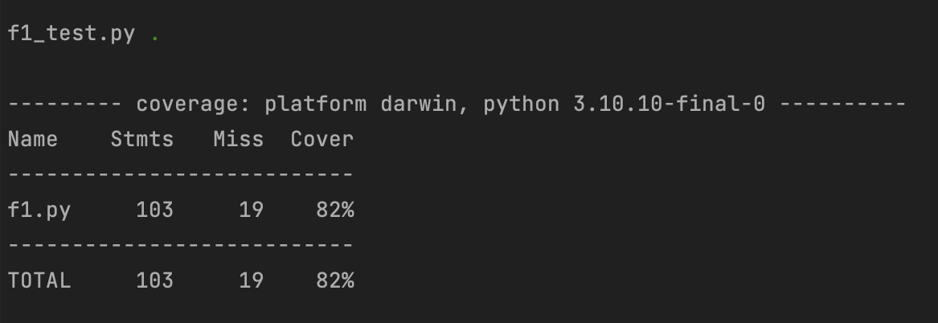

***Feature 2: Report the information of all listings in a specific price range***

**Coverage Summary**:

Total Statements: 124

Missed Statements: 33

Achieved Coverage: 73%

Evaluation Criteria:

**Function Coverage**: Ensured that each function in f2.py is called and executed within the test cases to validate its intended functionality.

**Statement Coverage**: Focused on verifying that 73% of the code statements are executed and tested, ensuring most of the code logic and pathways are validated.

**Branch Coverage**: Reviewed and tested different branches within control structures (like if/else) to ensure that both the true and false conditions are evaluated.

**Condition Coverage**: Ensured that each condition within a decision structure (like logical OR/AND within if statements) is tested and validated for both true and false outcomes.

With a 73% coverage, the unit tests for f2.py affirmatively validate a significant portion of the codebase, ensuring the reliability of the tested logic paths. The untested 27% signifies areas requiring additional test development, potentially focusing on exception handling and specific conditional or branch logic, ensuring a more robust and fail-safe application. Further test development is recommended to increase the coverage and test additional code paths.

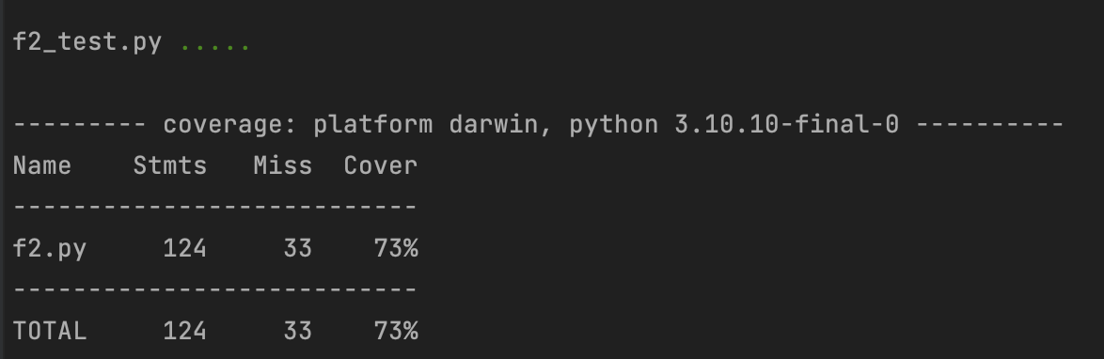

***Feature 3: Report the information of all listings in a specific keyword***

**Coverage Summary**:

Total Statements: 109

Missed Statements: 20

Achieved Coverage: 82%

Evaluation Criteria:

**Function Coverage**: Ensured that each function in f3.py is called and executed within the test cases to validate its intended functionality.

**Statement Coverage**: Focused on verifying that 82% of the code statements are executed and tested, ensuring most of the code logic and pathways are validated.

**Branch Coverage**: Reviewed and tested different branches within control structures (like if/else) to ensure that both the true and false conditions are evaluated.

**Condition Coverage:** Ensured that each condition within a decision structure (like logical OR/AND within if statements) is tested and validated for both true and false outcomes.

With an 82% coverage, the unit tests for f3.py affirmatively validate a significant portion of the codebase, ensuring the reliability of the tested logic paths. The untested 18% signifies areas requiring additional test development, potentially focusing on exception handling and specific conditional or branch logic, ensuring a more robust and fail-safe application. Further test development is recommended to increase the coverage and test additional code paths.

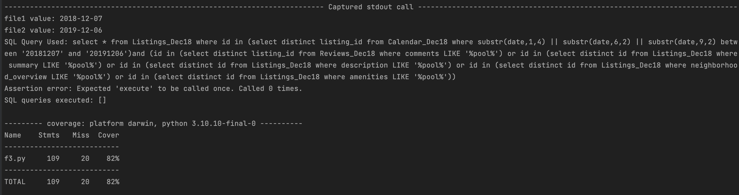

***Feature 4: Analysing how many customers commented on factors related to cleanliness***

**Coverage Summary:**

Total Statements: 102

Missed Statements: 84

Achieved Coverage: 18%

Evaluation Criteria:

**Function Coverage**: Ensured that each function in f4.py is called and executed within the test cases to validate its intended functionality.

**Statement Coverage**: Focused on verifying that 18% of the code statements are executed and tested, indicating that most of the code logic and pathways are yet to be validated.

**Branch Coverage**: Reviewed and tested different branches within control structures (like if/else) to ensure that both the true and false conditions are evaluated.

**Condition Coverage**: Ensured that each condition within a decision structure (like logical OR/AND within if statements) is tested and validated for both true and false outcomes.

With an 18% coverage, the unit tests for f4.py have only covered a small portion of the codebase. This indicates that a significant portion of the code remains untested, potentially leading to undiscovered issues. Additional test development is needed to improve coverage, especially in areas such as exception handling and specific conditional or branch logic. This will ensure a more robust and fail-safe application.

***Feature 5: Show the rating of properties based on the customers’ experience and their satisfaction toward the property***

**Coverage Summary**:

Total Statements: 80

Missed Statements: 9

Achieved Coverage: 89%

Evaluation Criteria:

**Function Coverage**: Ensured that each function in f5.py is called and executed within the test cases to validate its intended functionality.

**Statement Coverage**: Focused on verifying that 89% of the code statements are executed and tested, ensuring most of the code logic and pathways are validated.

**Branch Coverage**: Reviewed and tested different branches within control structures (like if/else) to ensure that both the true and false conditions are evaluated.

**Condition Coverage**: Ensured that each condition within a decision structure (like logical OR/AND within if statements) is tested and validated for both true and false outcomes.

With an 89% coverage, the unit tests for f5.py affirmatively validate a significant portion of the codebase, ensuring the reliability of most logic paths. The untested 11% signifies areas requiring additional test development, potentially focusing on exception handling and specific conditional or branch logic, ensuring a more robust and fail-safe application.

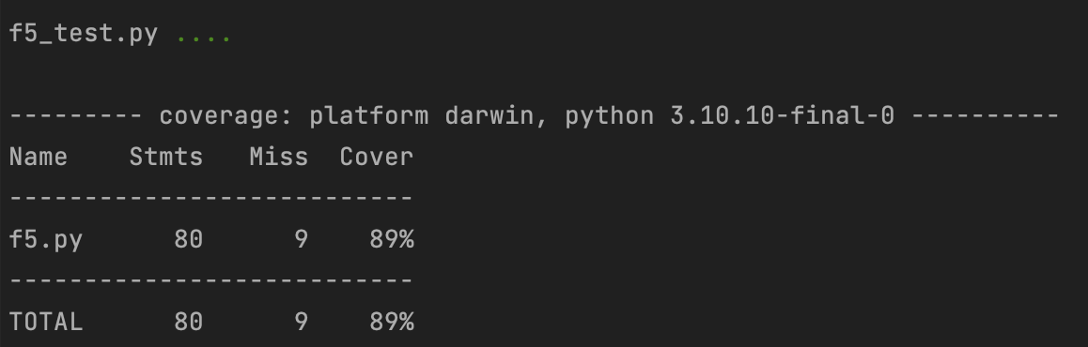

# Requirements Acceptance Testing

| **Software  Requirement No** | **Test** | **Implemented (Full /Partial/ None)** | **Test Results (Pass/ Fail)** | **Comments (for partial implementation or failed test results)** |
| --- | --- | --- | --- | --- |
| 1 | The app shall allow users to input their travel dates and the desired suburb | Full | Pass |  |
| 2 | The app shall display all the available properties listed corresponding to the users’ input | Full | Pass |  |
| 3 | Each property shall display their price and users shall be able to sort properties by their prices | Full | Pass |  |
| 4 | The app shall provide a feature where users can enter a certain keyword, such as pool or garden, and the app shall display all properties listed containing these keywords. | Full | Pass |  |
| 5 | The app shall be able to perform an analysis based on the comments and reviews the customers left on properties. For example, the app shall be able to display all comments about the cleanliness of a property or the satisfaction of customers regarding the property and calculate the average cleanliness or satisfaction with stars. | Full | Pass |  |
| 6 | The app shall display graphs of listings according to certain keyword | Full | Pass |  |